Abstract

We discuss methods for measuring application launching time and decreasing launching time.

INTRODUCTION

We introduce a method for measuring application launching time by inserting monitoring functions into Android operating system

1. App Launcher

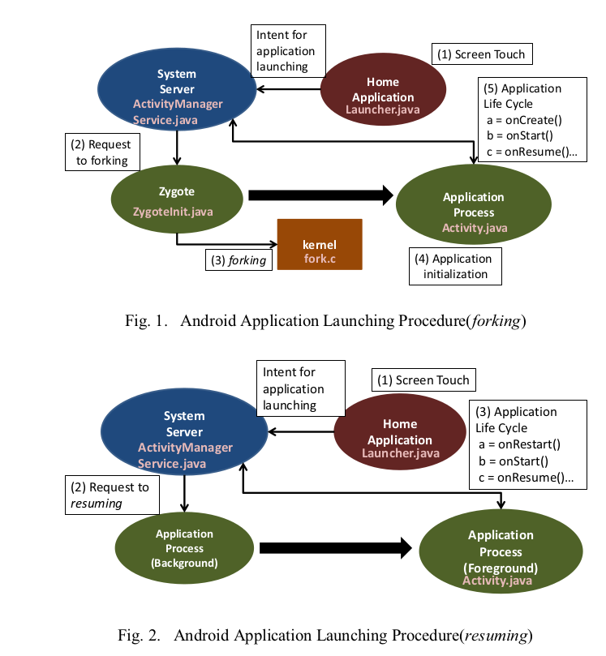

1. Launch Analyzing

We inserted the monitoring code into the source code of Android application framework, Android runtime, and libraries.

In this paper, we define “start time of launching” as “time of screen touch”, and defined “end time of launching” as “time of calling onResume()”.

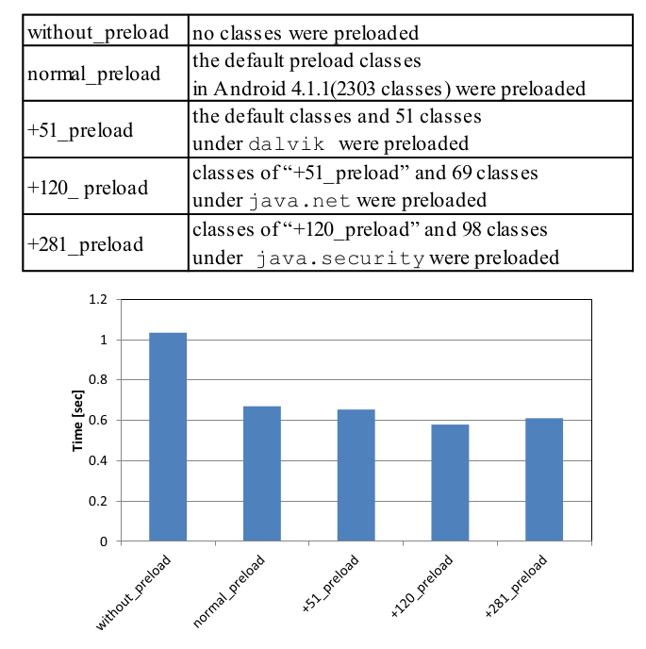

1. Decreasing Launching Time

1.Zygote stays with some important classes loaded

2.we discuss the relation between the number of preloaded classes and the application launching time.